SuccessFactors Exclusion List (SF_EXCL)
- Go to Success Factors Exclusions table.
Path: Root > Set Up HCM > FL Custom > Compensation Control > Success Factors Exclusions
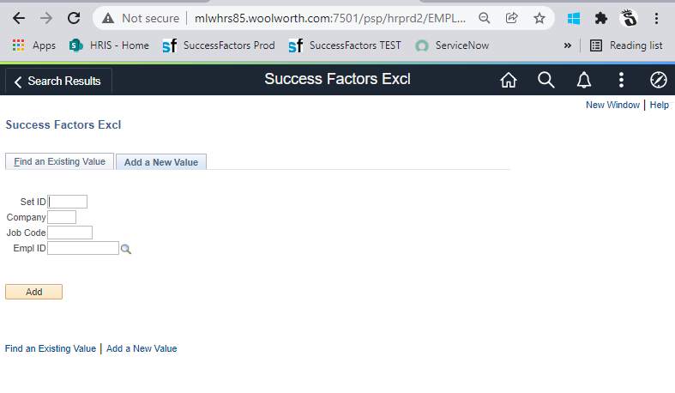
- For a new employee update, click “Add a New Value” tab and enter Empl ID.
Note: To maintain an existing value instead, use the “Find an Existing Value” tab.
- Enter the Empl ID. Click Add.

- Enter Effective Date and Status. The compensation team will provide the status* (description of status listed at the bottom of this document).
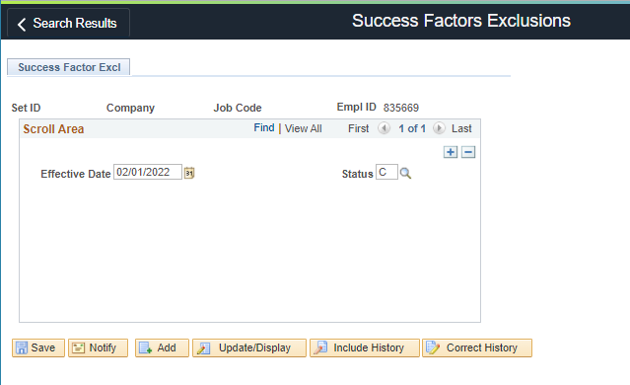
- Click Save.
- If necessary, click Add to make additional entries.
- For validation, go to Query Manager/Viewer and run the query “HRIS_SF_EXCLUSIONS”.
Note: The table name is “SF_EXCL”

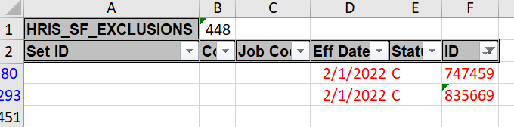

END

*This is the description of functionality for each status provided by IT (12/3/21):
This table is used in four different modes:
- Based on effective dating and effective status logic, if the company is found (with no job code) then that entire company is excluded from the feed.
- When processing employees if both the employees company and job code matches the entry on the table then the flag is set so that this associate is not eligible (lump sum and merit)
- When processing employees if only the job code matches and the company is blank then the flag is set so that this associate is not eligible (lump sum and merit)
- A 4th mode that this page/table will now help with the feeding of data to SF, the ‘EMPLID ID’ field. There are two ways in which this new mode will work. As seen in the first screen shot below, is an example of having an override of the ‘Compensation’ and ‘Merit’ flags. No matter what the program tries to set the flags too, if the program finds an employee on this table and the STATUS is an ‘A’ the program will send the data over to SF’s with a ‘TRUE’ in the flags. In the second screen print you will see the exact opposite, no matter what the program set’s for the flags if the program finds an override and the STATUS is an ‘I’ then the program will send the data over to SF’s with a ‘FALSE’ in the flags.
- The ‘C’ will denote Compensation Flag will be turned on only. The merit flag will be turned off. It keeps employees on the comp form but greys them out so they wont contribute to the budget.

